Bible Basics

Abraham had one son named Issac. Issac had two sons, Esau and Jacob. Jacob had 12 sons. (God changed Jacob’s name to Israel). His sons would eventually become the 12 Tribes of Israel.

As a side note: The 11th son was Joseph, but there is no “Tribe of Joseph”. Joseph had two sons named Ephraim and Manasseh. They were divinely assigned tribe status. However, the Tribe named after the third eldest son of Jacob, named Levi, was reserved by God as His priests. They were assigned lands and duties but could not own property as “inheritance.” Their livelihood was supported by the tithes and offerings of the people. They were also judges and teachers of the people.

Upon entering into the Promised Land, Joshua divided the land between the 12 Tribes, and he also assigned 48 cities to Levites. Those Levites who were not given specific Priestly duties were part of the Levitical support network that was strategically placed throughout the nation.

There are three passages that should be considered for the sake of clarity: Exodus 20:1-6, I Kings 11:1-5, I Kings 14:22-24.

Note two Maps:

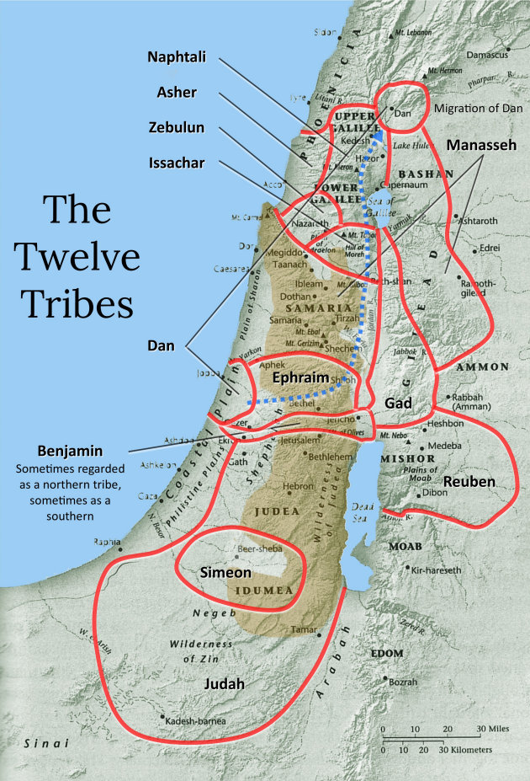

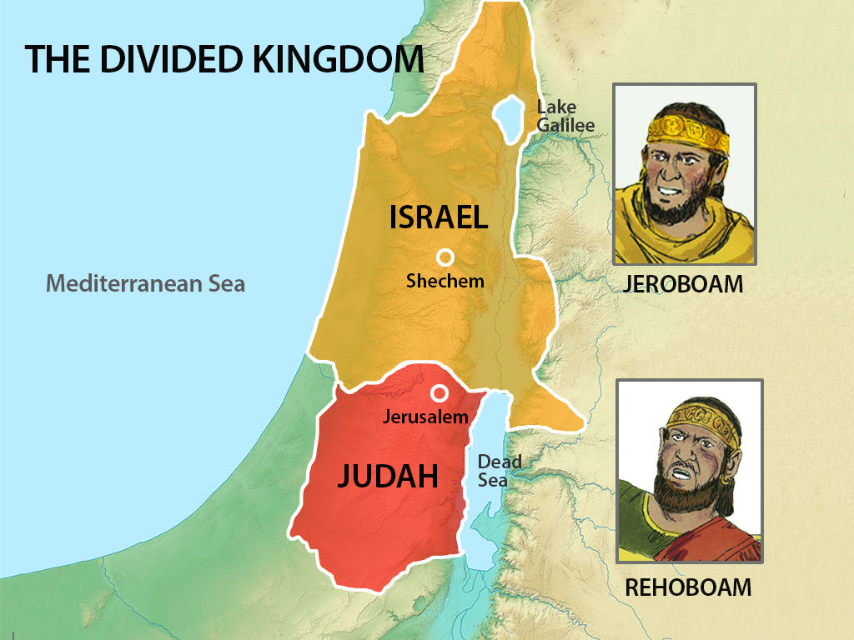

The Split

As we studied in the previous lesson, there was a division that happened just after Rehoboam became King. The previous passages would be the cause of God allowing or orchestrating the division of the Nation. Consider I Kings 12:16-24

The Split of the Northern Tribes sounds similar to what is often referred to as a “church split.” A church split is what happens when a portion of a congregation separates and starts a completely different congregation. These are almost always the result of irreconcilable differences and/or sin within the leadership ranks. The ultimate measure of success of church splits, as to God’s Will, in these matters is Time. (As is the case with the separation of the Northern Kingdom from Judah.) The Northern Kingdom separated from Judah in more ways than one.

Additionally, as it pertains to “Church Splits,” typically neither congregation appears to become as strong as the original unified group. However, when the Leadership of a congregation is properly focused, that congregation is blessed to survive and thrive. On the other hand, when the Leadership of a congregation is unfocused on the things of God, they tend to drift away from God and His Favor.

Leaders of congregations are important for the longevity and success of the congregation.

**Life Lesson #51** - The best leaders are prayerful men and women, whose ultimate goal is pleasing God, and not man. The worst spiritual leaders are people who are selfish and sinful. Proverbs 16:12, Proverbs 29:2, Proverbs 29:12

A Great Promise wasted.

King Jeroboam’s rise and fall is one of the great mysteries of God’s Sovereignty. According to I Kings 11, young Jeroboam was a prominent leader who was an official under Solomon. The Bible describes him, in I Kings 11:28.

The Lord sent a prophet named Ahijah to pronounce a great word over his life. Upon learning about the prophecy, Solomon acted like Saul and intended to kill Jeroboam. Thereby making Jeroboam a popular figure in the hearts of many of the people. So much so, that as soon as Solomon died, the people called for Jeroboam to come represent them before King Rehoboam!

Consider I Kings 11:26-12:3

The fact that God offered him a great kingdom should not be overlooked! The Lord had divinely positioned Jeroboam in place as a direct result of the actions of Solomon. Jeroboam’s placement and access to the place of leadership was neither an accident nor a coincidence. Jeroboam’s sin was his choice, and the consequences will forever lie at his feet. The legacy of Jeroboam is that of sin. Even the subsequent division of the people was part of God’s plan.

The Bible is clear that the division was I Kings 12:15c, I Kings 12:24d, “…for the cause was from the LORD…”, “…for this thing is from me…”

The sin of King Jeroboam

Consider I Kings 12:25-33, I Kings 13:33-34

King Jeroboam acted quickly to solidify his authority. He made 3 horrible decisions:1. He established alternative worship sites. 2. He appointed false priests. (It is interesting that no one challenged Jeroboam, except the Prophets. Unlike the events recorded in Joshua 22.) 3. He created worship dates that were intentionally designed to prevent people from worshipping properly.

Associations with Egypt and their negative influence

It is noteworthy that two of the adversaries of Solomon found refuge in Egypt. It is also noteworthy that when Egypt raided Jerusalem, they took the wealth from the Temple and Solomon’s house. It would appear that Hadad and Jeroboam recommended such steps.

Another point worth noting is that the sin of Jeroboam involved symbols that he had seen during this sojourn in Egypt. Even the assignments of Priests could have been a result influenced by the Egyptian’s governmental structure. Plus, Solomon’s wife was from Egypt too.

**Life Lesson #52 -** A person’s associations can impact their decision making Knowing the associations of those in leadership can be telling.

**Life Lesson #53** - Pasts matter! This is not only true in business but in relationships too. (IE, a person who admires known criminals, may be susceptible to criminal behavior. A person who associates with drug users may be lured to revisit old habits.) Where people have been is worth noting. Who people associate with is worth noting too. Background checks can be very beneficial.

Consider Proverbs 28:7, I Corinthians 15:33, I Thessalonians 5:12-13

Homework: Jeroboam and Rehoboam and Abijam and Nadab. I Kings 11-15