What if?

As we mentioned in the previous lesson, the separation from Judah was clearly the Will of God. He orchestrated the entire separation in response to the blatant sin of Solomon. However, this should not infer that the subsequent actions of both Rehoboam and Jeroboam were also part of God’s plan. Both of those Kings had the opportunity and knowledge they needed to lead a peaceable and productive existence.

In a perfect world, both Kingdoms could have coexisted and worshipped together in harmony. The land was large enough, and the system of worship would have been possible under the guidance of the High Priests and Levitical order.

To be clear, there should have been a national repentance in Judah, and the Northern Kingdom should have wholeheartedly sought the Lord. With the two Kings working together to maintain the favor of God over their Promised Land. Imagine that?

Note two Maps:

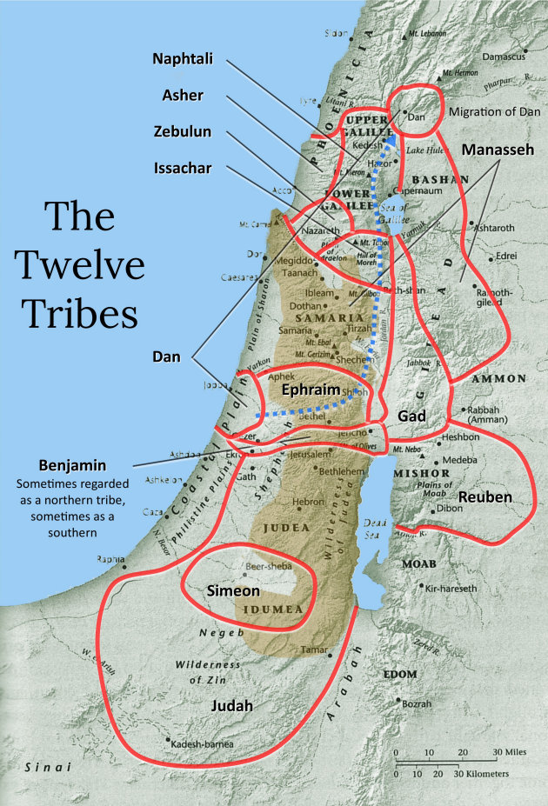

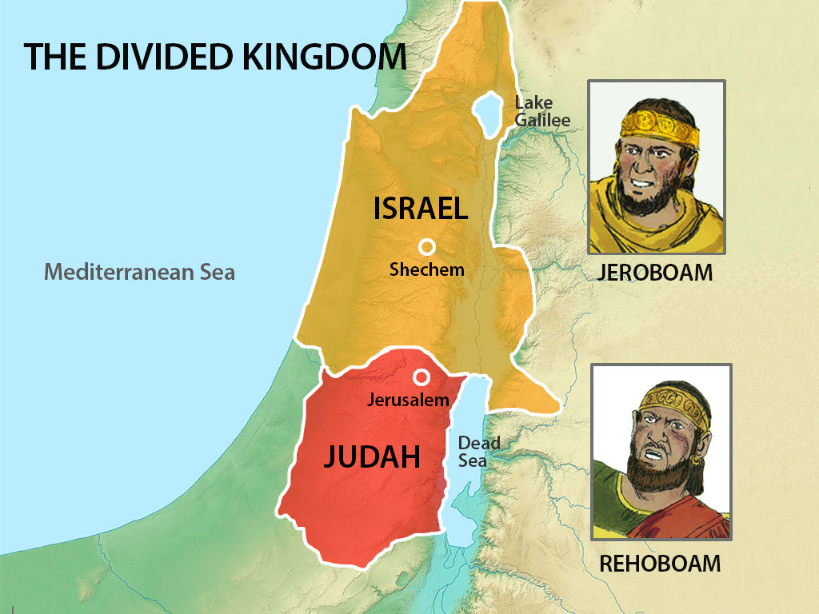

The Family Feud Begins

There are very sad verses found in I Kings 12:19-24, 14:30 and 15:6. The question remains, “Why?”

What were they fighting for? The simple solution to the conflict may lie in their unwillingness to submit themselves to the clear instructions and Will of God. If they had simply sought the Lord, the wars would NOT have happened. But because they were “…in their feelings…” they kept fighting one another. The phrase “…in their feelings…” is a modern way of describing what happens when someone allows their emotions to override their actions.

**Life Lesson #54 -** Learn to leave people alone! Sometimes, the best course of action is to leave someone alone. Even if they are clearly wrong. Leaving people alone can prevent escalation. Leaving folk alone can also prevent further misunderstanding. Like rescuing a drowning person, engaging with unholy people can be inherently risky.

**Life Lesson #55 -** War is a waste of time, energy, and resources. Retaliation and revenge are vicious cycles that must be broken. They can only be broken by refusal to participate. Step back and let life teach and the Lord handle things in His own way.

Consider Deuteronomy 32:35, Romans 12:19, (Hebrews 10:30).

There is a great prayer to say to oneself during those “step back times.” Pray for peace. Consider Matthew 5:9 and Romans 12:18.

King Rehoboam to King Abijah

We are not given many details about the death of Rehoboam, but we are given some insight into the background of his successor. Unfortunately, King Rehoboam followed in the ungodly ways of King Solomon. However, we do see that he was a kingly person who was groomed to lead.

Consider II Chronicles 11:18-23.

Abijah appears to be like a Princely person, who was expected to have a long-lasting career. But, unlike Saul’s 40-year reign, David’s 40-year reign, Rehoboam’s 17-year reign in Judah, and the 22-year reign of King Jeroboam over the Northern Kingdom, Abijam would only lead for 3 years.

The Deaths of King Jeroboam and King Abijah

Compare I Kings 11:34-38 with I Kings 14:7-11.

In the end, the Lord circled back and held King Jeroboam accountable for his deeds. Unfortunately, the damage to the nation had already been done. This is important to note: God always circles back. He will revisit and hold us accountable for His word. Always!

Consider Ecclesiastes 12:13-14, II Peter 3:9-14.

**Life Lesson #56 -** Expect all of God’s word to come to pass, every promise and every warning.

The most notable accomplishment of King Abijah was that he was the King that defeated King Jeroboam. II Chronicles 13 details the final battle of Jeroboam. It is noteworthy that the discourse recorded between Abijah and Jeroboam suggests that the Levites had maintained their commitment to the commands of the Lord.

**Life Lesson #57 -** It is possible to be holy in the midst of unholy people. Judah was guilty of the same sins that Israel was committing. However, there were enough holy people in place to prompt the favor of God. It may be that the righteous person in a family can be a blessing for the unrighteous.

Consider II Chronicles 13:1-22.

King Jeroboam suffered a tremendous loss that day, including over half of his chosen men and many of his prized cities. He did not recover.

Three Things all “Bad” Kings have in common.

Abijah’s short reign was marked by evil in the eyes of the Lord. Even though God had granted him victory over Israel, Abijah continued the same error as his father, Rehoboam, Abijah was not fully devoted to God.

Abijah is listed as a “Bad King.” Speaking of “Bad Kings,” there are some common characteristics that are listed in the Bible. Consider I Kings 15:1-3 and II Chronicles 12:13-16.

Bad Kings made the following mistakes:

1. They did NOT follow the good examples of King David.
2. They worshipped idols, like their fathers.
3. They ignored the strong admonitions of the Prophets sent by God.

**Life Lesson #58 -** God still sends messengers to warn us against disobedience. Those who heed to those warnings never experience the wrath of God. And neither do their children! If all the Bad Kings had repented, they could have changed the trajectory of the future. And so can we! When we listen and obey, we avert consequences.

As we follow this study, let’s keep asking ourselves the question…what if?

Homework: Study the Life of King Asa.